

Fontsize:27px Fontfamily:anticon Color:white background:# 202a43



Fontsize:22px Fontfamily: Fredoka One Color: white background:# 202a43



Fontsize:18px Fontfamily: Lato Color: # 010101



Fontsize:18px Fontfamily: Lato Color: # 010101 Font weight: bold



Fontsize:16px Fontfamily: Lato Color: # 939b9f



Fontsize:18px Fontfamily: Lato Color: white Font weight: bold

background: # 32b5e5



Fontsize:18px Fontfamily: Lato Color: white Font weight: bold

background: # 268fb5



Fontsize:16px Fontfamily: anticon Color: white

background: # 32b5e5



Fontsize:16px Fontfamily: anticon Color: white

background: # 32b5e5



Fontsize:16px Fontfamily: Lato Font weight: bold Color: white

background: # 32b5e5



Fontsize:36px Fontfamily: Lato Font weight: bold Color: white

background: # 32b5e5



Fontsize:16px Fontfamily: Lato Font weight: bold Color: # 32b5e5 Background: white



Fontsize:16px Fontfamily: Lato Color: black Background: # f9f9f9



Fontsize:17px Fontfamily: Lato Color: # 32b5e5 Background: # f9f9f9

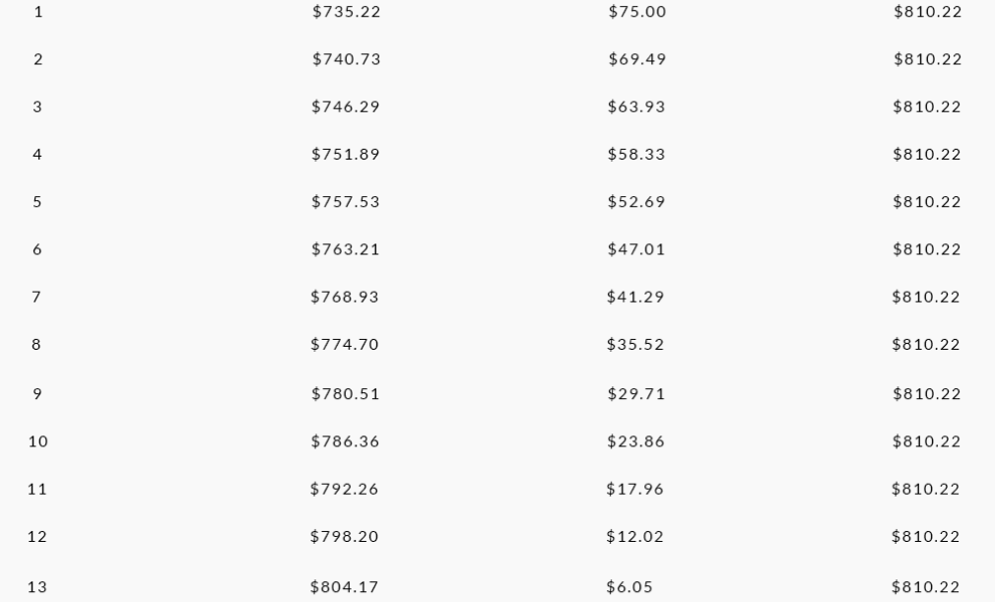

Fontsize:16px Fontfamily: Lato Color: black Background: # f9f9f9



Fontsize:18px Fontfamily: Lato Font weight: bold Color: white Background: # 32b5e5